**Gym Management System**

**1. Introduction**

The Gym Management System is a software application designed to streamline and automate various aspects of managing a gym or fitness center. It provides functionalities for managing members, instructors, equipment, and class schedules, as well as handling searches.

**Technologies Used**

* **Classes, Interfaces, Abstract Classes:** Used to define the structure and behavior of various components of the system.
* **MAUI GUI:** Utilized to create the user interface for the application, providing a cross-platform experience.
* **Exceptions:** Implemented to handle errors and exceptional situations gracefully, ensuring the stability of the application.

**2. Functionality**

The core functionality of the Gym Management System includes:

* Member management: Adding, updating, and removing member information.
* Instructor management: Managing instructor details and schedules.
* Equipment management: Tracking equipment inventory and maintenance schedules.
* Class scheduling: Creating and managing class schedules for different activities.
* Search actions: One can search through various parameters.

**Implementation**

* **Classes:** Defined classes such as **Member**, **Instructor**, **Equipment**, and **ClassSchedule** to represent entities in the system.
* **Interfaces:** Used interfaces like **Members** and **Instructors** to define common behaviors for managing members and instructors.
* **Abstract Classes:** Used abstract classes like **Person** to define common properties and methods for entities like **Member** and **Instructor**.

**3. Classes and Inheritance**

**Defined Classes**

* **Member:** Represents a gym member with properties like name, contact information, and membership status.
* **Instructor:** Represents an instructor with details such as name, contact information, and class schedule.
* **Equipment:** Represents gym equipment with properties like name, quantity, and maintenance status.
* **ClassSchedule:** Represents a schedule for a class, including the instructor, time.

**Inheritance**

* Used inheritance to create a hierarchy of classes, such as **Member** and **Instructor** inheriting from **Person**, which contains common properties like name and contact information.

**Interfaces and Abstract Classes**

* Used interfaces like **Members** and **Instructors xaml files** to define common behaviors for managing members and instructors.
* Used abstract classes like **Person** to define common properties and methods for entities like **Member** and **Instructor**.

**4. MAUI GUI**

The Gym Management System utilizes MAUI GUI to create a user-friendly interface for the application. MAUI's cross-platform capabilities allow the system to run seamlessly on various devices and operating systems, providing a consistent user experience.

**5. Exceptions**

Exceptions are used in the Gym Management System to handle errors and exceptional situations, ensuring the application's stability and reliability. For example, exceptions are used to handle scenarios such as invalid user inputs, database errors, and network issues.

Example in Instructor.xaml.cs  
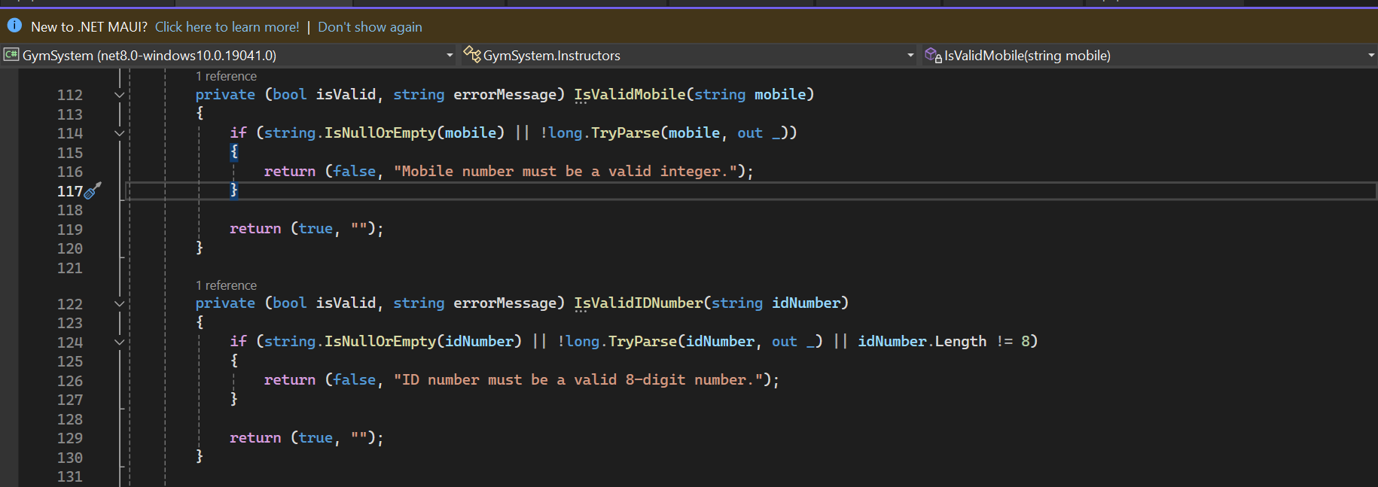

**6. Conclusion**

The Gym Management System is a comprehensive software application designed to simplify and automate gym management tasks. By leveraging technologies such as classes, interfaces, abstract classes, MAUI GUI, and exceptions, the system provides a robust and user-friendly solution for managing all aspects of a fitness center.

**UML CLASS DIAGRAM**

FirstName

LastName

Email

Mobile

Gender

JoiningDate

PlanDuration

**Member**

Name

Description

Quantity

**Equipment**

Name

Password

**Admin**

FirstName

LastName

Email

Mobile

Gender

**Instructor**

**Entity-Relationship Diagram (ERD)**

Equipment

Member

Instructors

Manage

Equipment

**UI MOCKUP PLAN   
  
HomePage**

**X**

**GYM SYSTEM**

PROCEED

WELCOME TO GYM SYSTEM

**Login  
  
  
Member page  
Instructors  
Equipment**

Login

Username

Pass

**X**

**GYM SYSTEM**

**Member Page**

**X**

**GYM SYSTEM**

Register

Registration Form

**Instructor Page**

**Equipment Page**

**X**

**GYM SYSTEM**

Register

Registration Form

**Instructor page**

**X**

**GYM SYSTEM**

Register

Registration Form

**SYSTEM VIEW**

* 1. **Welcome Page**

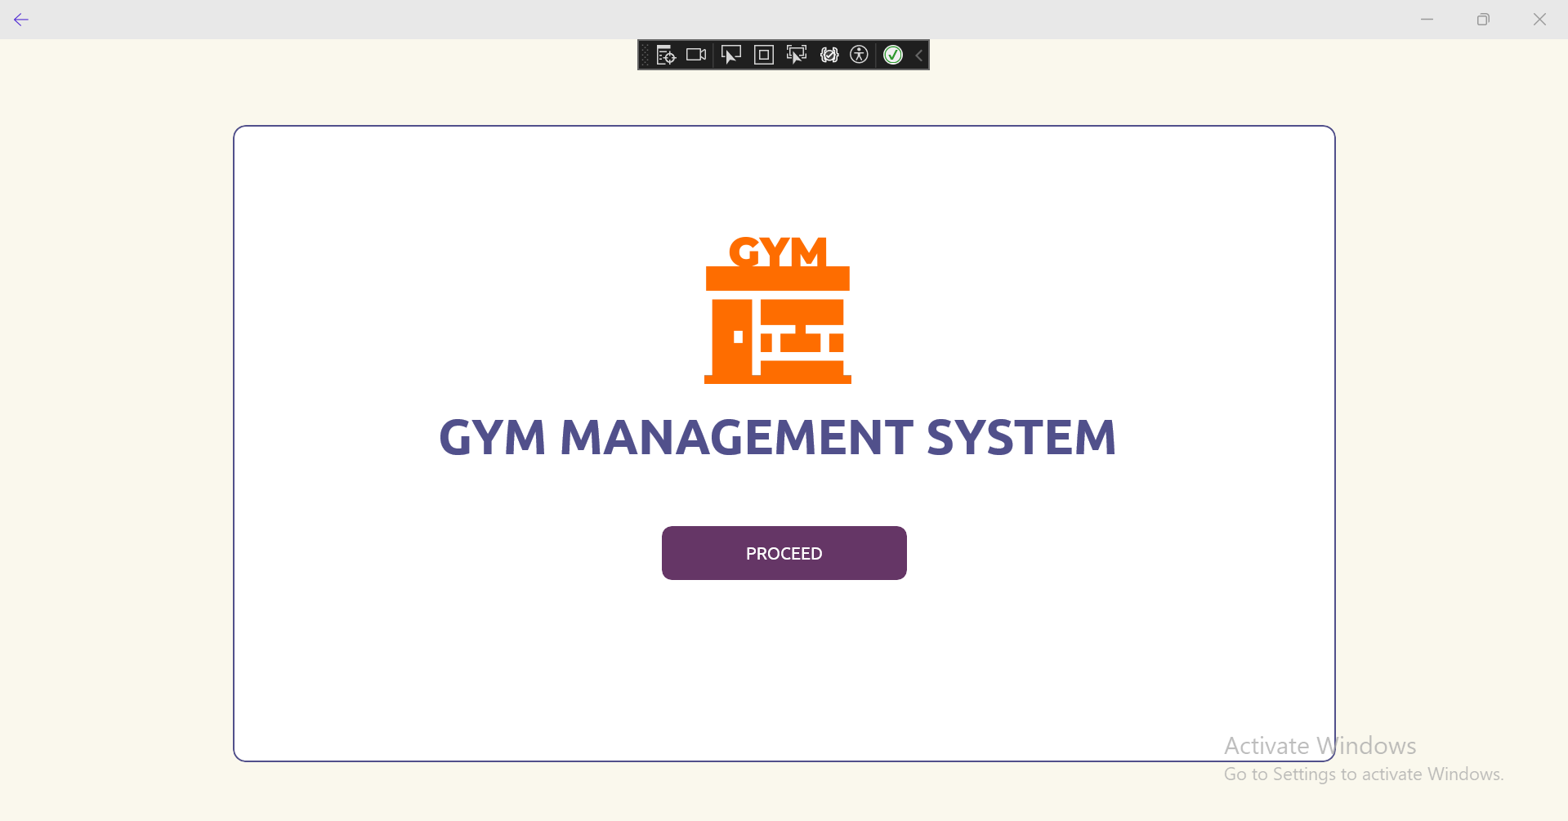

* 1. **Login Page**

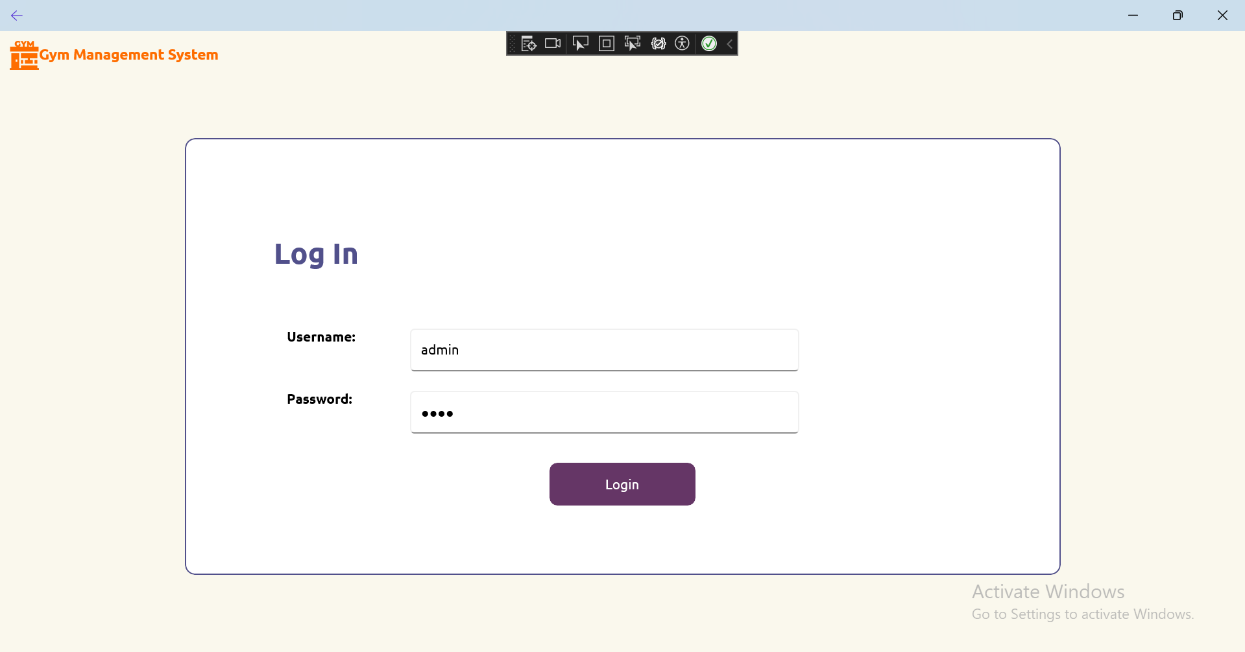

* 1. **Home**

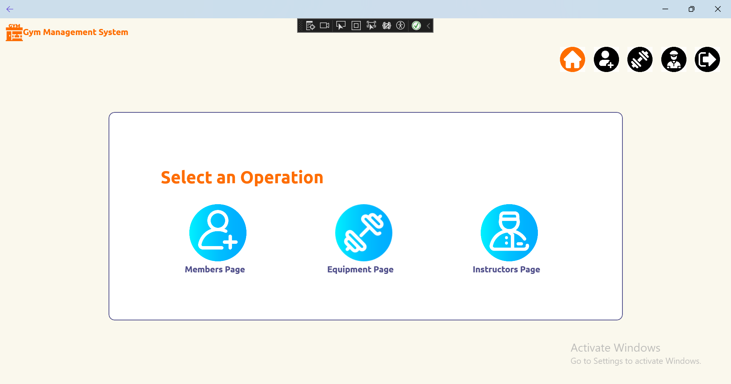

* 1. **Member page**

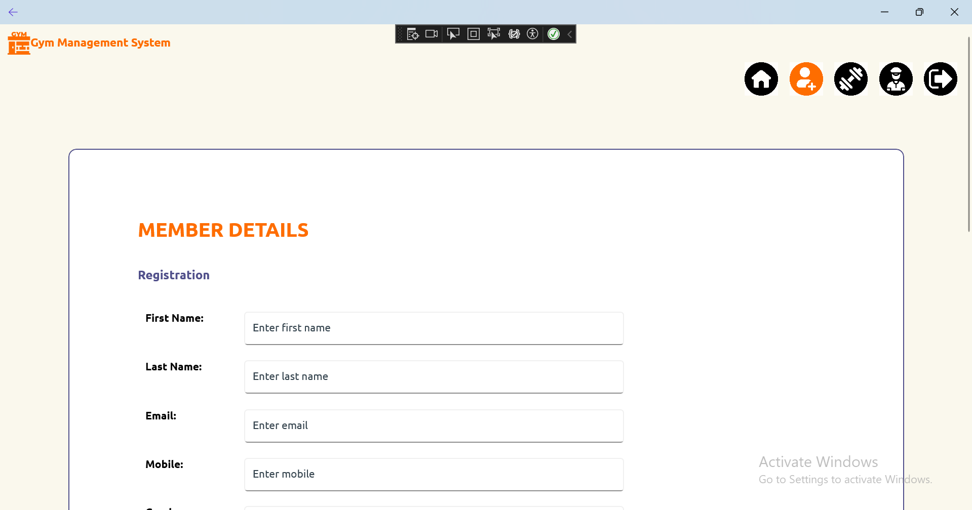

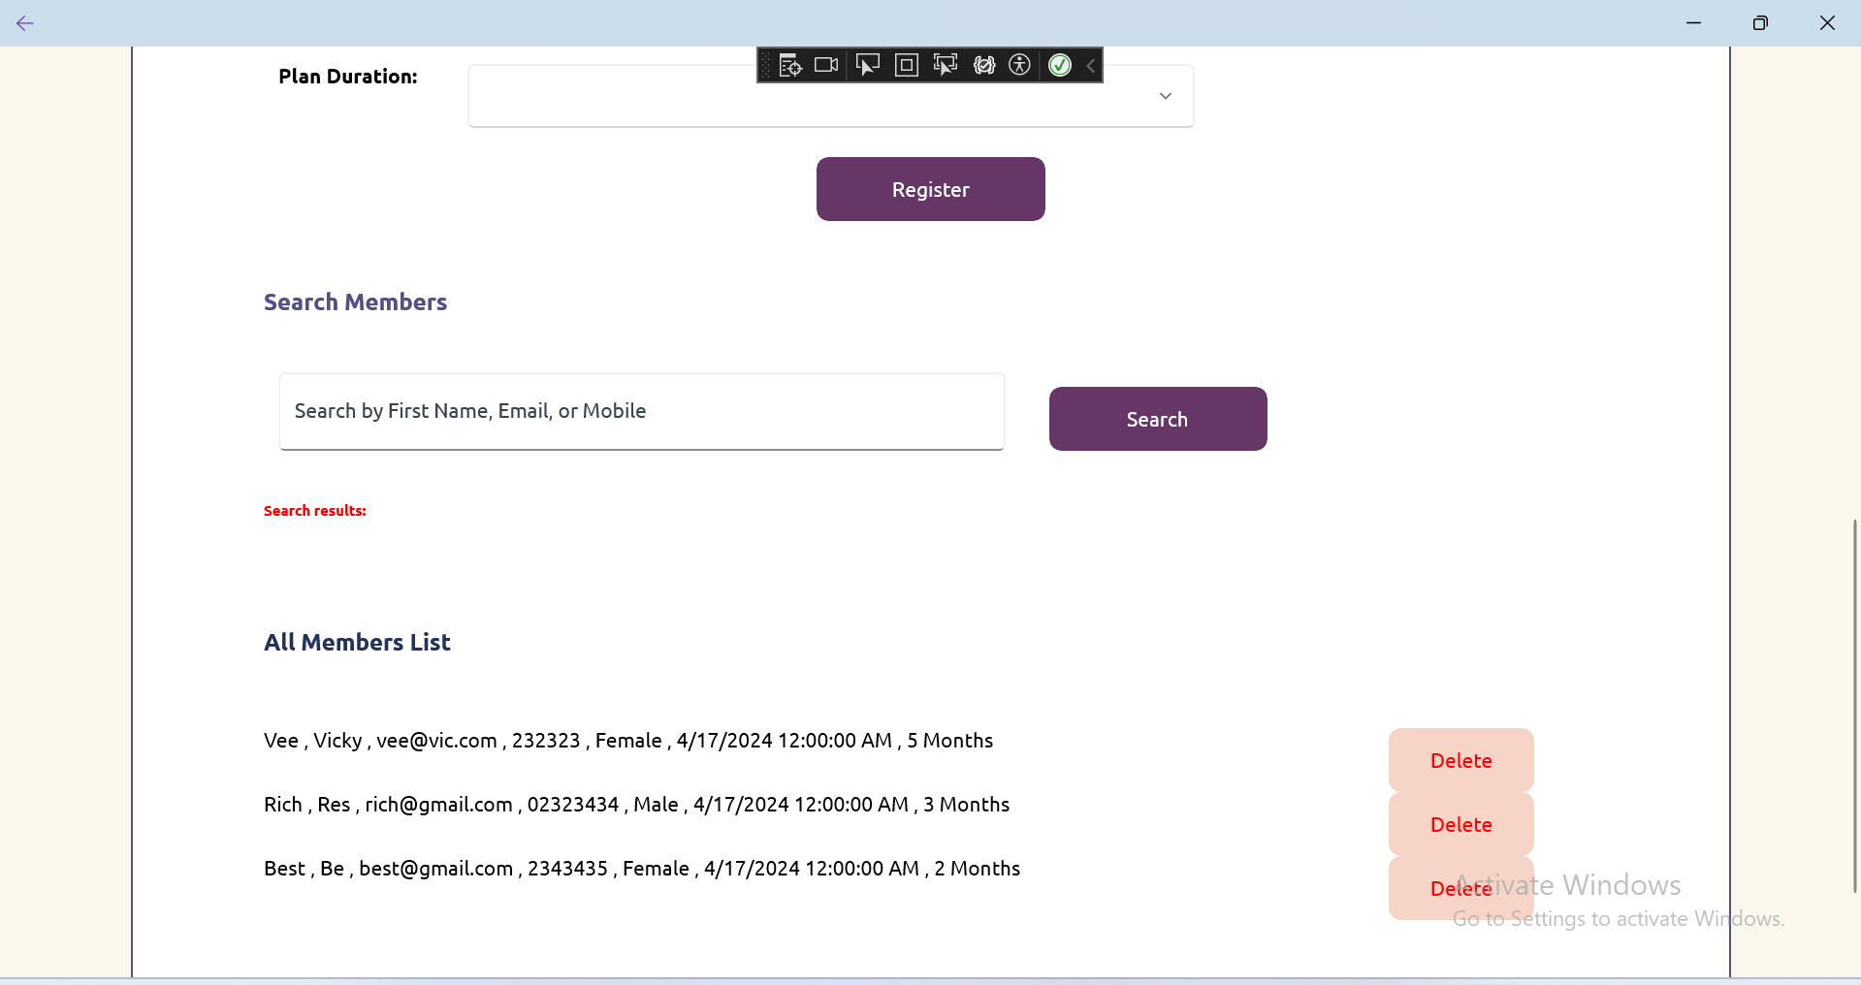

* 1. **Equipment Page**

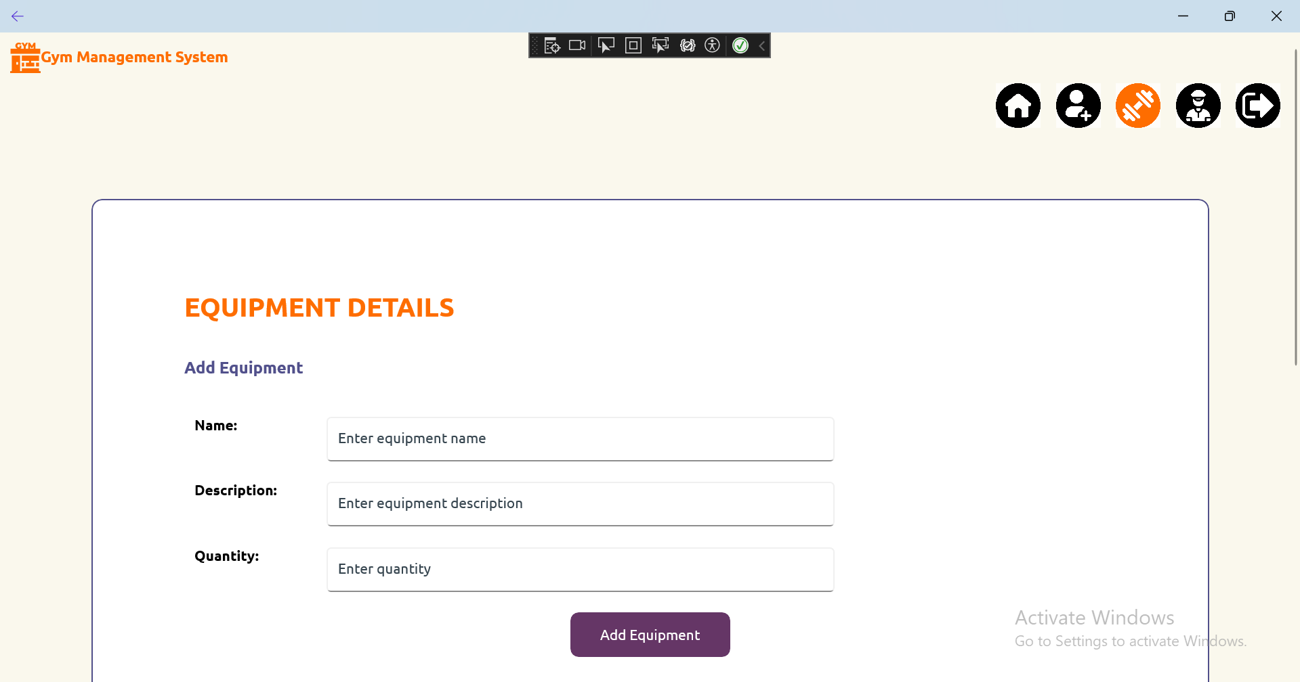

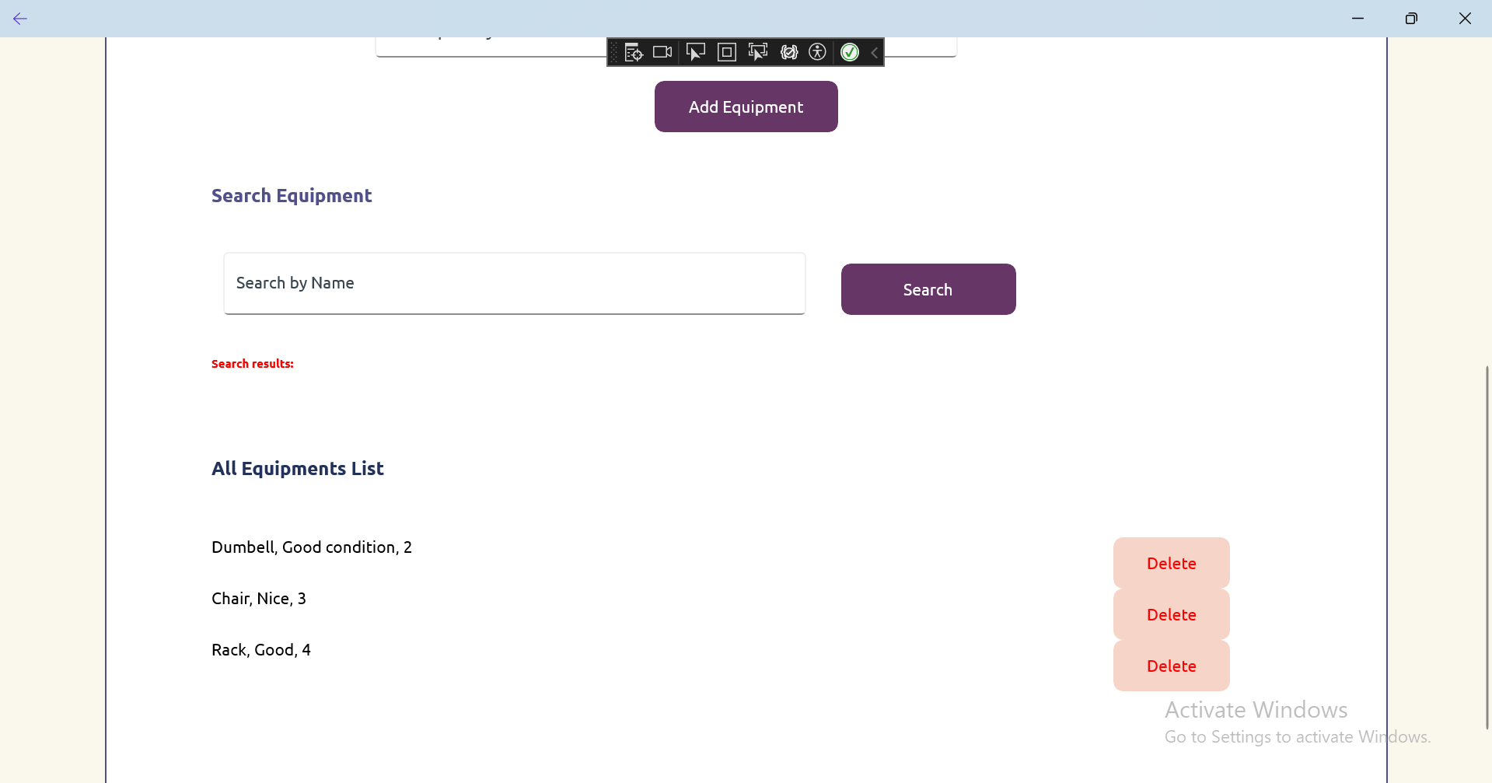

* 1. **Instructors Page**

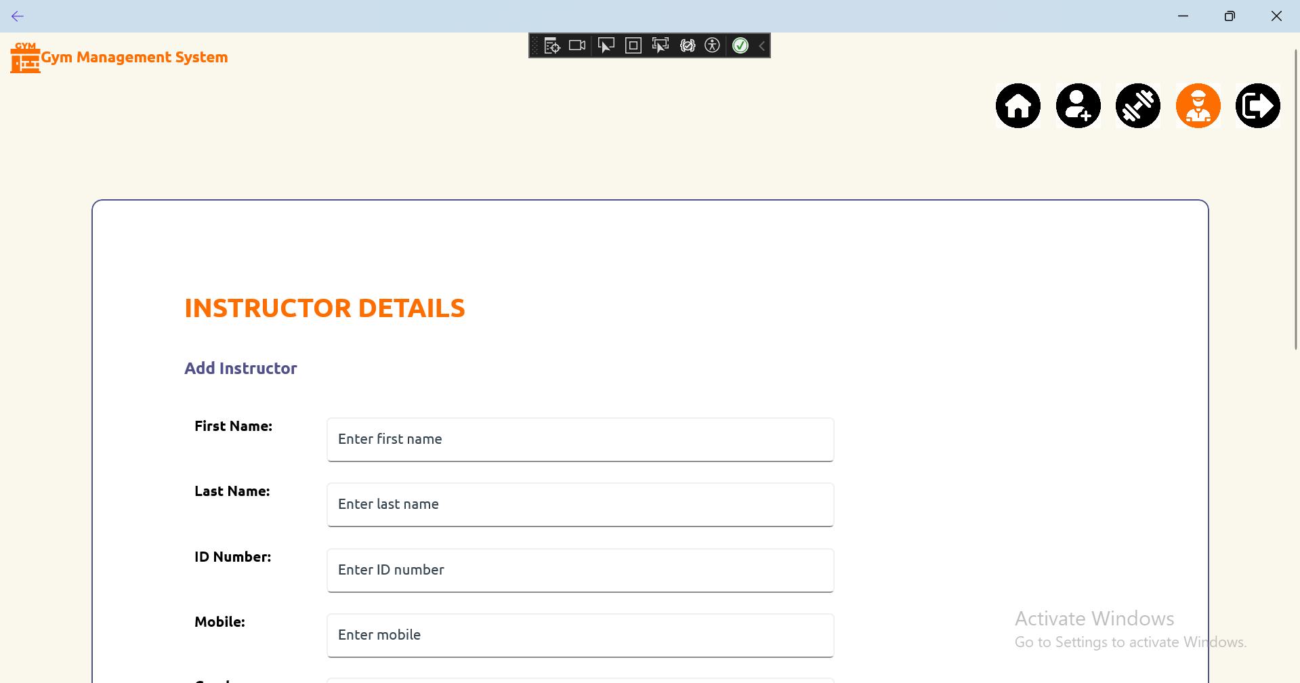

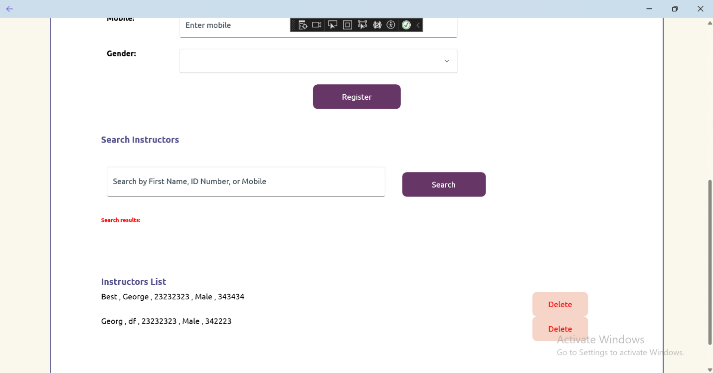

* 1. **Filled Entries**

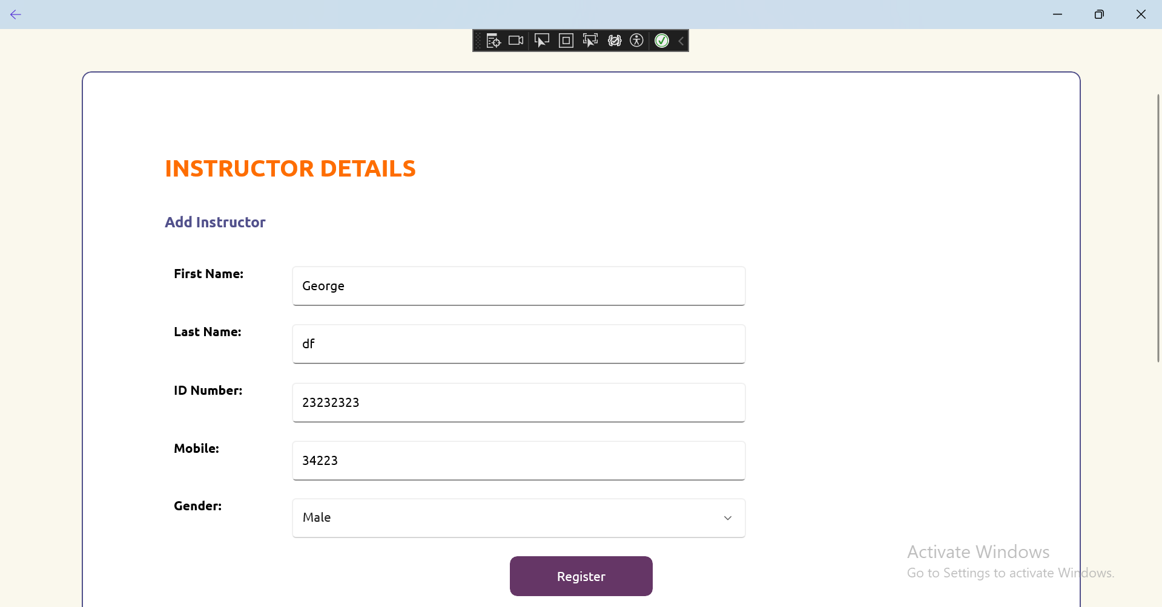

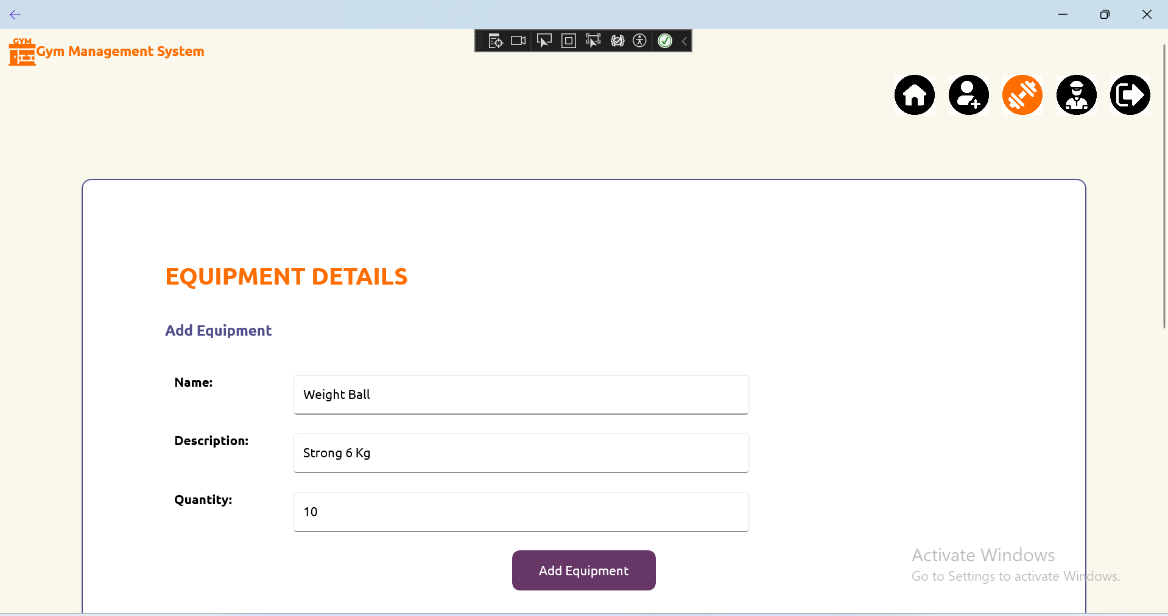

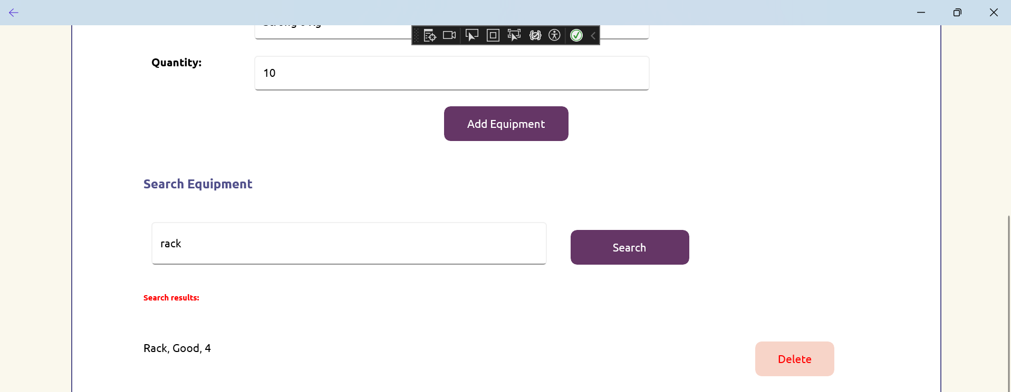

**OUTPUT SCREENSHOTS**

* 1. **Equipments.csv**

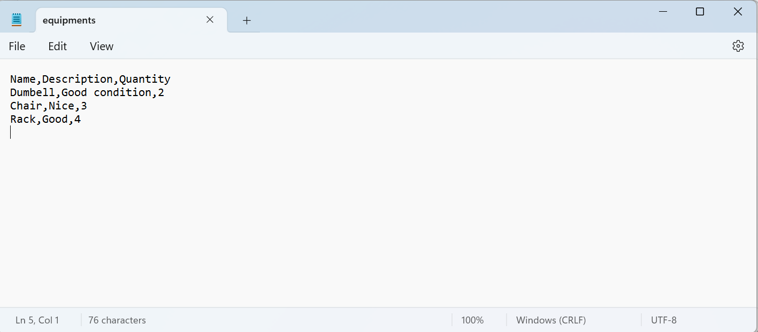

* 1. **Instructors.csv**

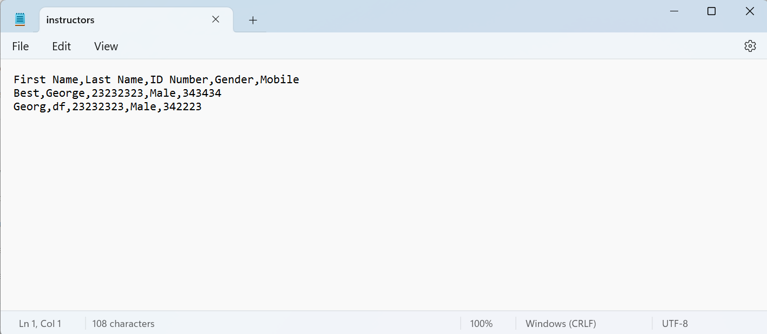

* 1. **Members.csv**

